**Written Assignment 1**

1. Run GaussianBlurImage and SeparableGaussianBlurImage with sigma = 2, 4, 8 on “Seattle.jpg”. How many seconds does it take to run each function? How long do you think it would take to run each with sigma = 32?

2. Which of the following filters are separable, i.e. can be computed from a combination of 1D horizontal and vertical filters? Why?

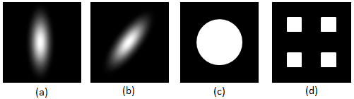

2. What is the best amount of blur to apply when downsampling Moire.gif by 8x (pressing “Half Size” 3 times)? Does downsampling “Seattle.jpg” require the same amount of blur?

3. What is the best bilateral input values (sigmaS and sigmaI) for removing the jpg artifacts in “Seattle.jpg” without blurring the image’s details?

4. Can you find an edge in “TightRope.png” that is visible to the human eye, but does not have a strong response from the Sobel edge detector?

5. If you rotate the image 20 times by 2 degrees, does it produce the same result as rotating the image by 40 degrees? If not, why?

6. If you apply blur before applying FindPeaksImage you can remove many noisy edges. What is the best amount of blur to apply to Gogh.png to find the “cleanest” edges? Does using BilateralImage to blur the image before applying FindPeaksImage produce better edges? In addition to answering these questions, please turn in your best peak edge image called “GoghEdge.png”.